**Question 1**: What percentage of users make a purchase in their first 90 days after sign up (excluding their sign up day)?

Total_users_with_signup_date = 23841

Users_purchased_in_90_days = 6369

Percentage= 27%

**Question 2**: What percentage of users who purchased in the first 90 days received a message after their sign up date but before their first purchase date?

Users_purchased_in_90_days = 6369

User_received_messages = 2653

Percentage = 42%

**Question 3**: Is the number of messages a user receives in their first 90 days (excluding their sign up date) predictive of their propensity to make one or more purchases in the following 90 days? (yes/no)

**The answer is No.**

First, Let’s look at how many people didn’t purchase in 90 days and they actually received a message.

User_no_purchase_in 90_days = 17472

User_no_purchase_received_messages_in_90days = 16363

Percentage = 94%

So 94% of users who didn’t purchased actually receive a message within 90 days after their sign up date (excluding their sign up day).

Next, Let’s look at this plot. The bar chart shows how many messages each user received, the line chart shows how many they purchased. Depending on the relationship shows in the figure, I can say there is no correlated relationship between the number of messages and the number of purchase.

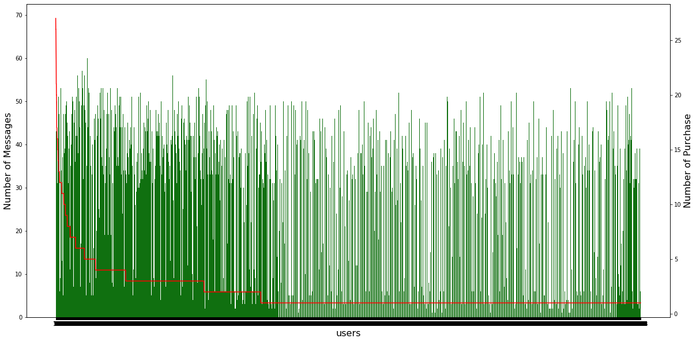

Figure 1. The number of product purchased VS The number of messages (in 90 days after signup date)

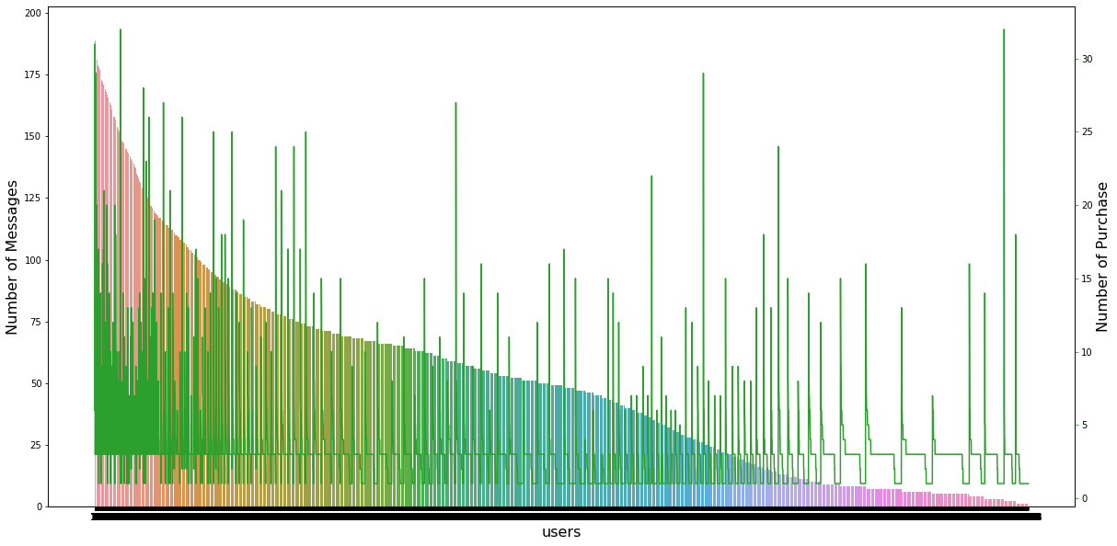  
Figure 2. The number of product purchased VS The number of messages (no time limit)

Creative questions and answer:

1. How many users signup each month?

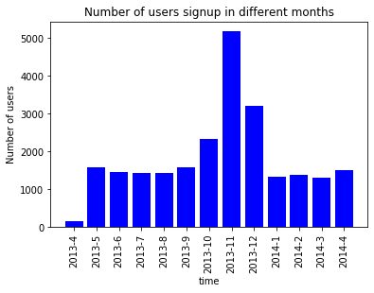

1. Top 20 users who purchased most

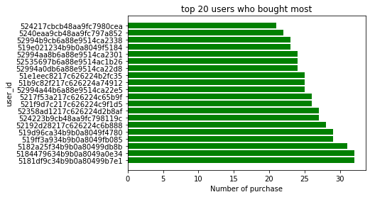

1. Top 20 users who got most number of messages

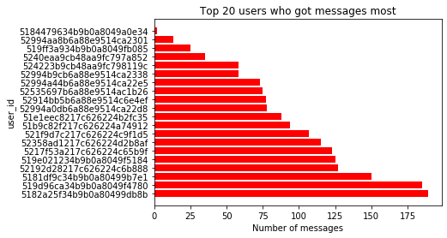

For the Top 20 users who purchased most, actually they got the most messages too. But in the large scale, the number of messages received and the number of product purchased has no directly relationship.( see Fig.1 and Fig.2)